**Viktor Logodazhki**

**Anime Character Simulation Battle Arena**

**User Guide**

1. **Starting the Program:**
   * Run the program from the IDE or text editor you are using.
   * The welcome message will guide you through the initial options.
2. **Creating Characters:**
   * Choose to create a character by entering 'y' when prompted.
   * Follow the on-screen instructions to input character details:
     + Character Type (e.g., Sorcerer, DemonSlayer)
     + Name
     + Special Ability
     + Attributes: Strength, Constitution, Dexterity, Intelligence, Wisdom, Charisma, and additional attributes based on the character type.
3. **Using Pre-loaded Characters:**
   * If you choose not to create a character (by entering 'n'), the program will load pre-defined characters from a JSON file for simulation.

**Simulation:**

* Once characters are loaded or created, the program will automatically simulate battles based on their Damage Per Second (DPS) stats.
* The characters will be sorted and displayed on the leaderboard in descending order of their DPS.

**Exiting the Program:**

* After viewing the leaderboard, you can close the program by simply closing the IDE or text editor or stopping the program altogether.

**Demonstration:**

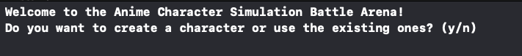

If the entered character is ‘n’ or any other one beside ‘y’:

If it is ‘y’:

